***Assignment # 01***

***Submitted To:***

*Sir Numan Mazhat*

***Submitted By:***

*QURA-TUL-AIN*

*17581556-064*

***Submission Date:***

*5th April 2021*

***Course:***

*System Integration & Architecture*

***Semester:***

***8th IT (B)***

**

***Plot the Data On Google Play Store App Rating***

In this assignment, plot the data of Google Play Store App Rating. Data set has a lot of missing values in it. The Rating column has more missing values than others.

In this remove the missing values clean the data set and plot the data.

**import** **pandas** **as** **pd**

**import** **numpy** **as** **np**

**import** **matplotlib.pyplot** **as** **plt**

*google_data.boxplot()*

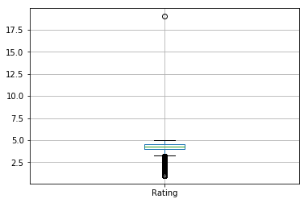

*google_data.hist()*

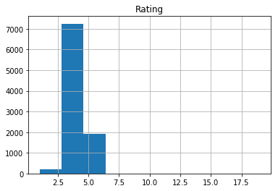

***After data cleaning of rating column, the histogram looks like this:***

google_data.hist()

Output:

array([[<matplotlib.axes._subplots.AxesSubplot object at 0x000001E193764128>]], dtype=object)

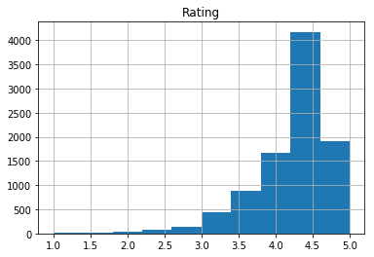

**Visualize the data:**

plt.figure(figsize=(12,5))

plt.plot(x, 'ro')

plt.xticks(rotation=90)

plt.show()

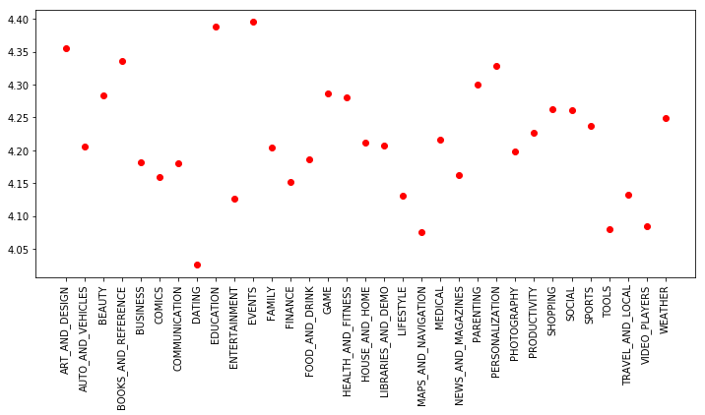

plt.figure(figsize=(16,5))

plt.plot(x,'ro', color='r')

plt.xticks(rotation=90)

plt.title('Category wise Rating')

plt.xlabel('Categories-->')

plt.ylabel('Rating-->')

plt.show()

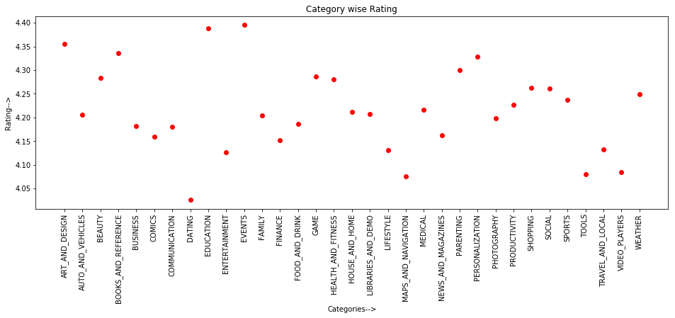

plt.figure(figsize=(16,5))

plt.plot(y,'r--', color='b')

plt.xticks(rotation=90)

plt.title('Category wise Pricing')

plt.xlabel('Categories-->')

plt.ylabel('Prices-->')

plt.show()

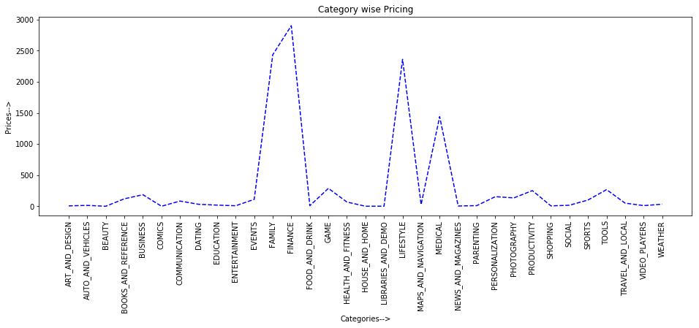

plt.figure(figsize=(16,5))

plt.plot(z,'g^', color='g')

plt.xticks(rotation=90)

plt.title('Category wise Reviews')

plt.xlabel('Categories-->')

plt.ylabel('Reviews-->')

plt.show()

